Meet the Sta 101 TA’s + Our Office Hour Tips

## Carly Grossfield carly.grossfield@duke.edu

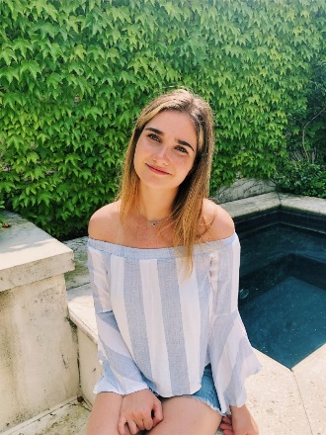My name is Carly Grossfield, and I am a sophomore at Duke. I am from Bethesda, Maryland right outside of Washington, DC. I am majoring in Economics with a finance concentration and minoring in Spanish.

I think the most effective way to utilize office hours is by coming prepared with questions and taking time before to try to understand the material.

## Daniel Deng di.deng@duke.edu

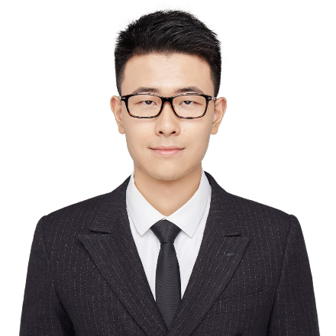I am Daniel and currently a second year Master in our department. I studied physics and statistics in my undergraduate at University of Illinois, Urbana-Champaign. The reason why I chose to continue on statistics is that it has such a wide range of practical applications that it gives me a good chance to find my interest among all the fields. During this Summer, I have been doing TAship for Sta101 and research assistant for professor Mike West with a group of people in 84.51. My current plan is to apply for PhD in this fall, so maybe I can share more experience on that after I get my application finished.

## Emily Gentles emily.gentles@duke.edu Head TA

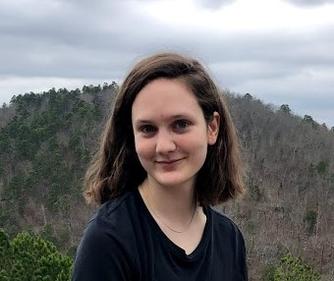Hello, my name is Emily (she/her/hers) and I’m a PhD student in the Statistical Science program. I’m originally from Arkansas and enjoy hiking, embroidery, and gardening. A fun fact about me is that I studied abroad for a semester in Russia!

My advice for students is to remember that office hours are dedicated to helping you throughout this course so please don’t hesitate to attend and ask questions! It’s useful if you come with specific questions or problem areas but I also encourage you to join and listen to the questions of others.

## Emre Yurtbay emre.yurtbay@duke.edu

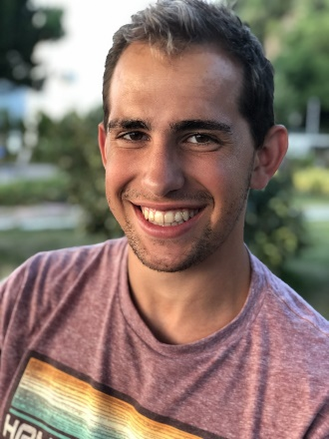Hi everyone! My name is Emre Yurtbay, and I am a Master's student in the Statistical Science program. I received my undergraduate degree in Statistics from Rice University, and I enjoy running, drawing, and playing soccer.

I look forward to getting to know many of you this semester during TA office hours! Even though they will be virtual, don't hesitate to contact me or any of the other TA's with questions about the material and the homework problems.

## Evan Knox evan.knox@duke.edu

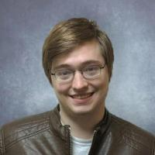Howdy everyone, I'm Evan!  I'm a PhD student from Athens, GA, by way of the University of Georgia.  Some of my interests that relate to this class include designing undergraduate statistics classes and communicating probabilities to the public.  Outside of statistics, I spend my time playing board games, competing in trivia contests, and watching college football.

My main advice would be to be mindful about what you want out of office hours and what (if anything) you need to put in beforehand to make that work best.  If you work best going through a problem asking small, clarifying questions when you get to something ambiguous, feel free to come right in and work on it.  If you're looking for a more full explanation of a topic or feel like something just isn't making sense with the rest of the material, it may make sense to strategically work ahead or back a little bit so that you have a probing question or two to fall back on in case your TA doesn't understand the mental conflict you're having.

## Joe mathews joseph.mathews@duke.edu

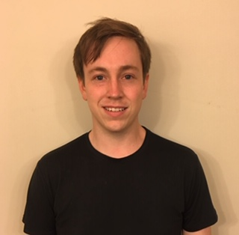Hi, my name’s Joe and I’m a PhD student in the statistical sciences department! I’m originally from Clarksville, TN and I like dogs and playing music.

Students should try to ask precise questions in office hours so that we can answer their questions efficiently. They should expect TAs to guide them towards the correct solution.

## Michael Sarkis michael.sarkis@duke.edu

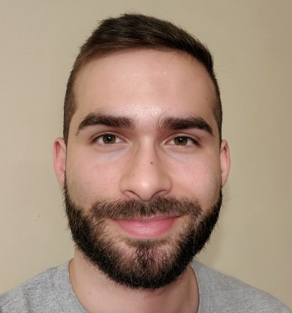I'm Michael Sarkis a first year Master's Student in Statistical Sciences. I'm originally from the Boston area and got my Bachelor's degree in Statistics and Economics from Cornell University. I'm a big Boston sports fan and especially enjoy analyzing sports statistics.

Everyone should feel welcome and encouraged to come to office hours and ask any questions they want. Whether its understanding a large topic or just a small clarification our TA team will help you work through the material to better your understanding of statistics.

## Molly Carson molly.carson@duke.edu

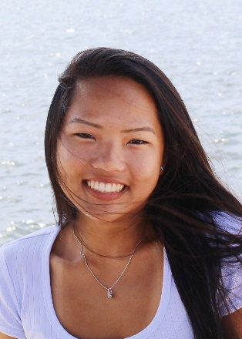 My name is Molly Carson, and I am a sophomore from Virginia Beach, VA. I'm majoring in Neuroscience on the Pre-med track. I love going to the beach, playing lacrosse, and trying different foods!

Never be afraid to come to office hours and ask as many/as few questions as you want - we are all here to help!

## Nadia Innab nadia.innab@duke.edu

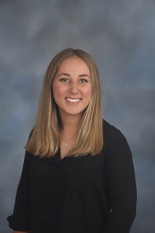My name is Nadia and I am a senior from Los Angeles, California majoring in Public Policy with minors in Statistics and Gender, Sexuality, and Feminist Studies. In my free time, I love baking, running, and watching Friends!

A piece of advice I have for attending office hours is to come with questions prepared, because it makes the time more productive!

## Richard Chen richard.chen3@duke.edu

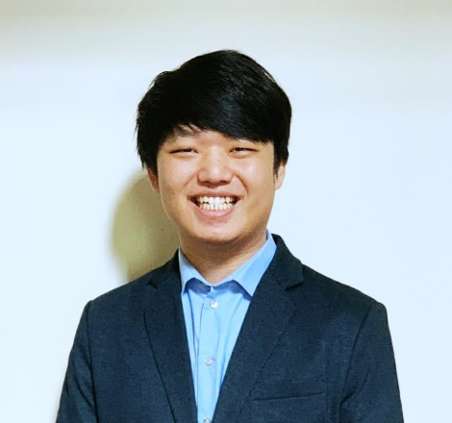My name is Richard Chen, and I am a senior double majoring in Statistics and Computer Science. I’m from Virginia Beach, Virginia, which is right by ocean, and so I enjoy to go fishing during my free time. I’m also a big fan of Duke Basketball, and have black-tented the past 3 years.

The biggest piece of advice I have for students is that students should not be afraid to ask questions about old or previously covered content, since new material often builds on initial concepts. In the past when I attended office hours myself, I would be embarrassed to ask the TA questions about basic concepts, but that only set me behind even more, so I would encourage students to ask me any type of question and I will do my best to help them.

## Sophie Riegel sophie.riegel@duke.edu

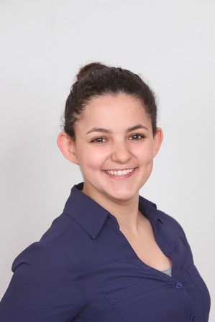I'm Sophie and I am a Sophomore. I am possibly majoring in Psychology with a minor in creative writing and a certificate in Decision Science. I am from Long Island, NY but my parents are moving to Durham in a few months. I am on the Quidditch team at Duke and I love to search for Nugget during my free time.

Here's my advice: Most of the TA's have taken this class before and know how it works. You can ask us ANYTHING, and the worst thing that can happen is the TA can say they don't know or they aren't allowed to tell you. But if you don't ask questions, you will not get answers. We can't tell you what's on the exams, but we can share what to expect, how to solve problems, we can troubleshoot Rstudio, and more. We're really not intimidating!

## Thea Dowrich thea.dowrich@duke.edu

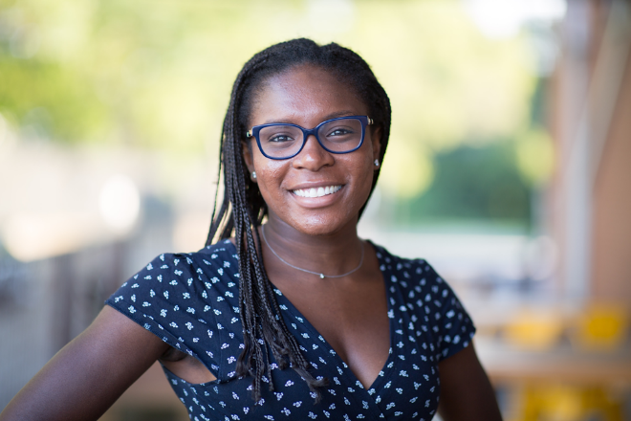Hi everyone, I’m Thea and I am a senior majoring in Public Policy with double minors in Chemistry and Statistics. My family and I have been living in Tokyo for the past 5 years, but I was born in Barbados and lived in Connecticut for most of my life. Outside of Duke, I love travelling and trying new restaurants in Durham!

With regard to the tips about office hours: It's largely a student-driven time, so they should come with questions prepared, but there aren't any restrictions on what questions they can ask, except maybe "What is the answer?" We can't give them the answers, but we can guide them through the problem and work through the process together and pinpoint where they are having difficulty.

## Younis Mahmoud younis.mahmoud@duke.edu

My name is Younis. I'm a 4th year undergraduate student from Seattle, WA, and I am currently finishing up my degree in Neuroscience with a minor in Chemistry and Philosophy (Yes, I know my academic choices are all over the place). A fun fact about me is that I can hold a handstand for a very long time, and I have a real passion for coffee which might've already been evident when I mentioned I'm from Seattle.

I think the best way to attend office hours is to recognize specific concepts you're unsure about and to ask TAs to help you find questions that involve those concepts. In the end, the goal of OH and us TAs is to help you understand course material so spend the time identifying what areas we can best help you in this course.

## Zeki Kazan zekican.kazan@duke.edu

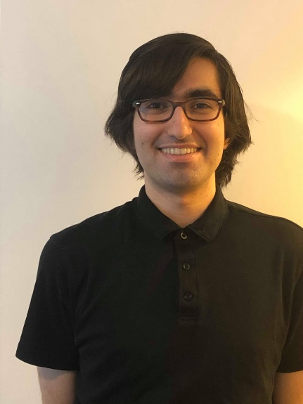I'm Zeki Kazan (he/him/his), a first year PhD student in statistical science. I'm originally from Long Beach, CA and got my Bachelor's at Reed College in Portland, OR. I'm half-Turkish (that's where the name comes from) and enjoy making cool Turkish food in my free time.

I'd say the biggest tip for office hours I have is to make questions as specific as possible. Saying "I can't figure out number 3" is much less effective than saying "I got stuck at this point in the question." Asking the TA to look over a problem is much less effective than asking the TA if your logic at a specific step makes sense.

Compiled by Emily Gentles